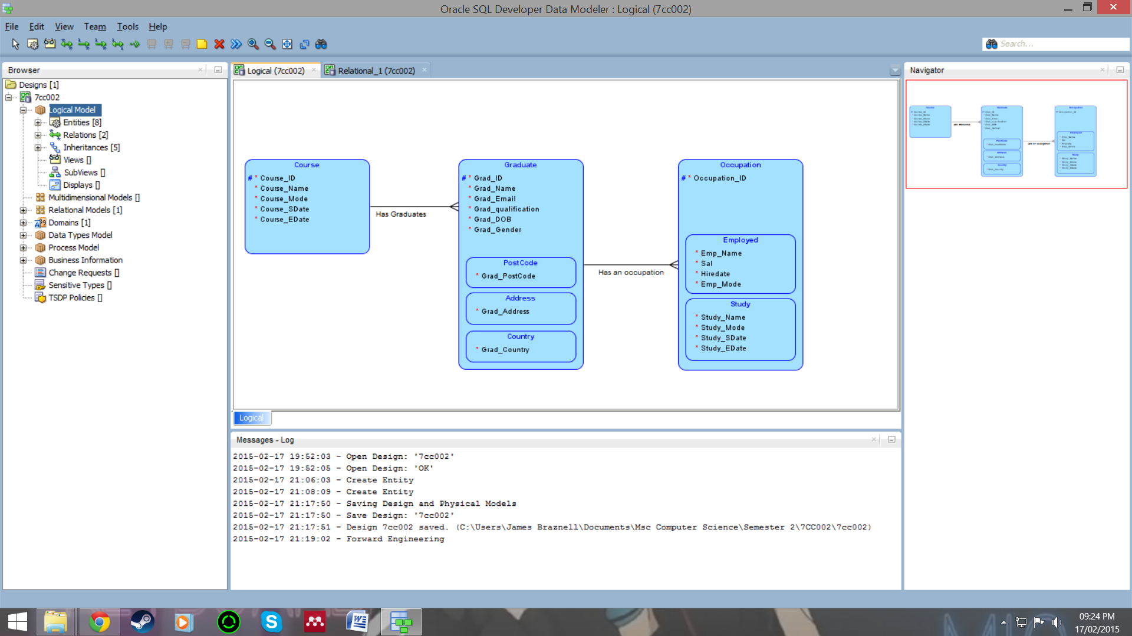**Logical Model:**

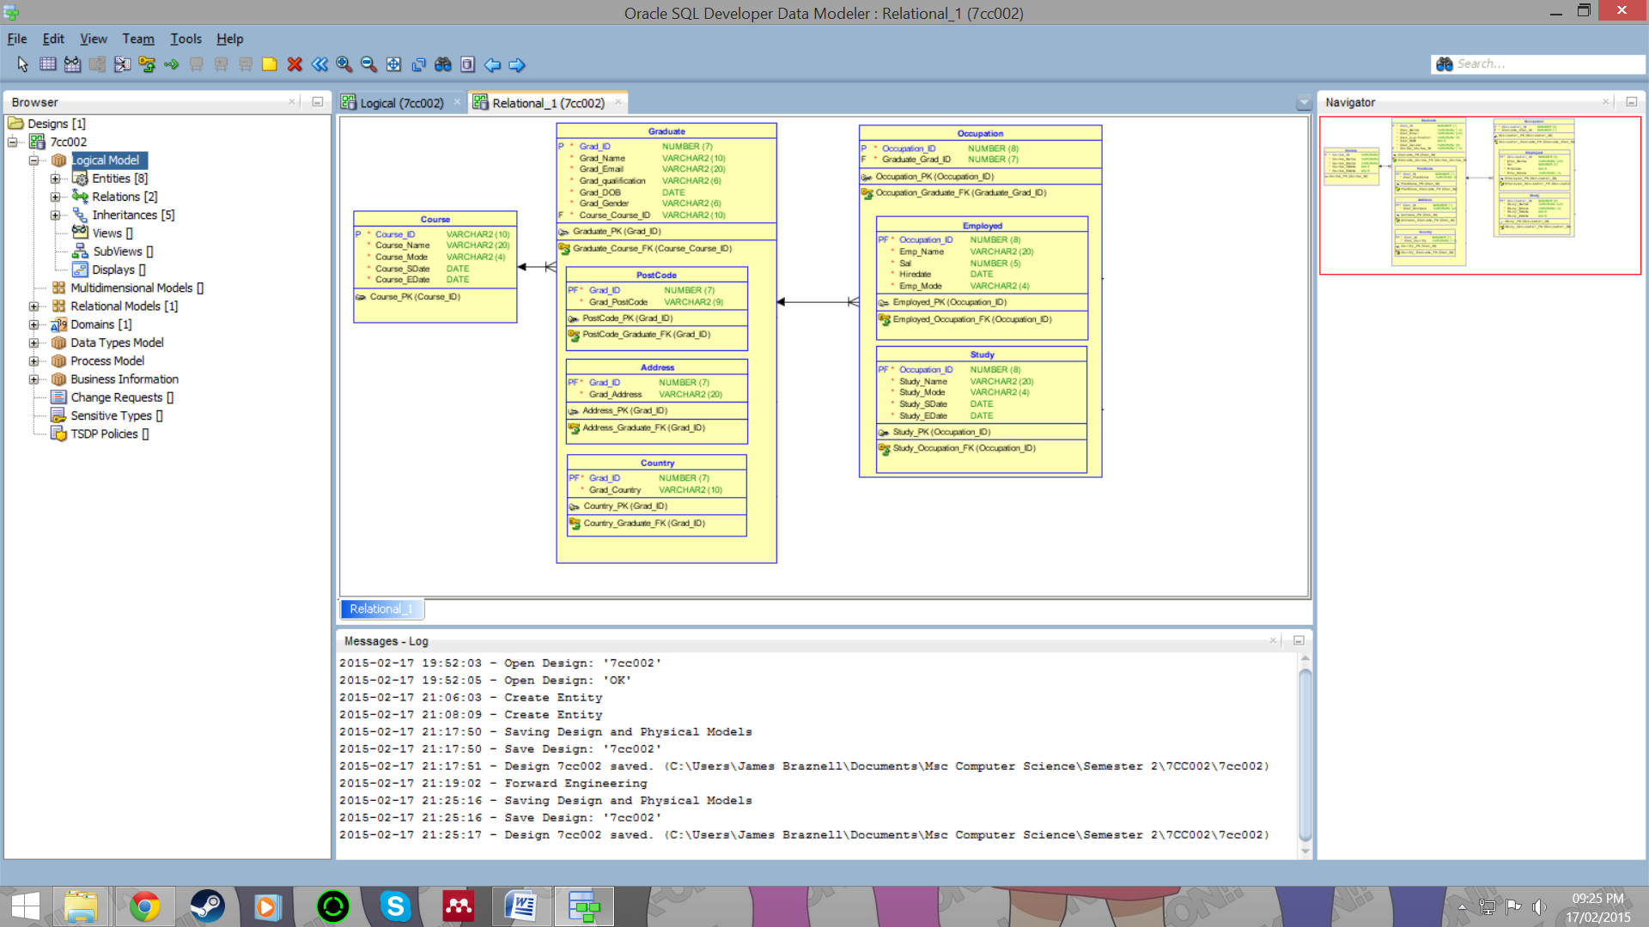**Relational Model:**

Added new entities as sub types of the graduate/occupation entities, sub entities inherit the primary key of the graduate/occupation table only, they also include their own attributes formerly from the graduate/occupation tables as they are specialised for said attributes.